Reset

What is Reset?
# Source: AI Source: Provided by: [Data Path: Persons Table -> ID Column: 1, Name_En Column: Motasem Essam] -> From: [ChatGPT] on [2/15/2026]
In Git, reset means moving the current branch (HEAD) to another commit, optionally changing the staging area and working directory.
It is used to undo commits or unstage changes, but unlike revert, it can rewrite history.

Simple idea
# Source: AI Source: Provided by: [Data Path: Persons Table -> ID Column: 1, Name_En Column: Motasem Essam] -> From: [ChatGPT] on [2/15/2026]
git reset = move HEAD backward (or to any commit)
Depending on the mode, it may:
- Keep your files unchanged
- Unstage changes
- Delete changes completely

Syntax
# Source: AI Source: Provided by: [Data Path: Persons Table -> ID Column: 1, Name_En Column: Motasem Essam] -> From: [ChatGPT] on [2/15/2026]
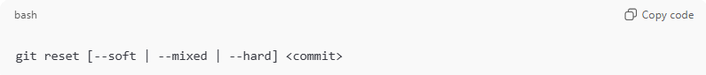
git reset [--soft | --mixed | --hard] <commit>
If no mode is given → --mixed is default

Types of Reset
# Source: AI Source: Provided by: [Data Path: Persons Table -> ID Column: 1, Name_En Column: Motasem Essam] -> From: [ChatGPT] on [2/15/2026]
1. --soft (Move HEAD only)
- Moves HEAD to another commit
- Keeps changes staged
- Does NOT change working files
Use case: undo commit but keep changes ready to recommit
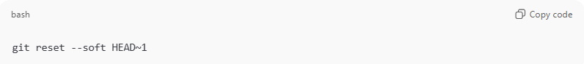
git reset --soft HEAD~1

2. --mixed (Default)
- Moves HEAD
- Unstages changes
- Keeps changes in working directory
Use case: undo commit and move changes back to unstaged
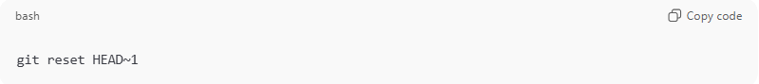
git reset HEAD~1

3. --hard (Dangerous ⚠️)
- Moves HEAD
- Deletes staged changes
- Deletes working directory changes
Everything after that commit is LOST
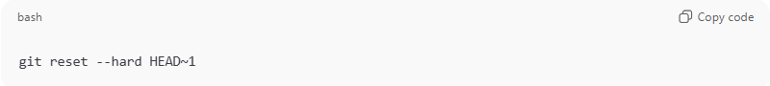
git reset --hard HEAD~1

Reset vs Revert
# Source: AI Source: Provided by: [Data Path: Persons Table -> ID Column: 1, Name_En Column: Motasem Essam] -> From: [ChatGPT] on [2/15/2026]
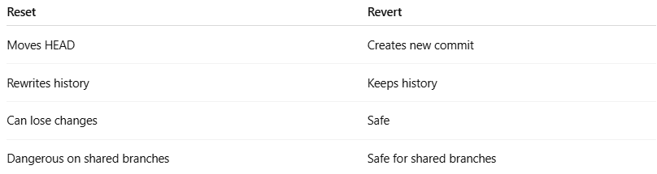
Reset | Revert
Moves HEAD | Creates new commit
Rewrites history | Keeps history
Can lose changes | Safe
Dangerous on shared branches | Safe for shared branches

Example Scenario
# Source: AI Source: Provided by: [Data Path: Persons Table -> ID Column: 1, Name_En Column: Motasem Essam] -> From: [ChatGPT] on [2/15/2026]
You made a bad commit:
- Want to fix and recommit → git reset --soft HEAD~1
- Want to edit changes again → git reset HEAD~1
- Want to erase everything → git reset --hard HEAD~1
- Want safe undo (public repo) → git revert <commit>

git reset with HEAD, HEAD~1, HEAD^

HEAD
# Source: AI Source: Provided by: [Data Path: Persons Table -> ID Column: 1, Name_En Column: Motasem Essam] -> From: [ChatGPT] on [2/15/2026]
HEAD = current commit (latest commit on your current branch)
So:
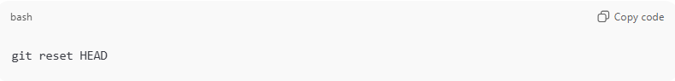
git reset HEAD
Means:
- Do NOT move to another commit
- Only unstage files (same as git reset --mixed HEAD)
- Your files stay unchanged
👉 Common use:
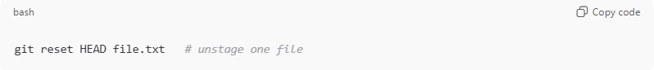
git reset HEAD file.txt # unstage one file

HEAD~1
# Source: AI Source: Provided by: [Data Path: Persons Table -> ID Column: 1, Name_En Column: Motasem Essam] -> From: [ChatGPT] on [2/15/2026]
HEAD~1 = one commit before current commit (parent commit)
So:
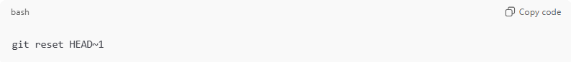
git reset HEAD~1
Means:
- Move branch back 1 commit
- Undo last commit
- Keep changes in working directory (default = --mixed)
Example history
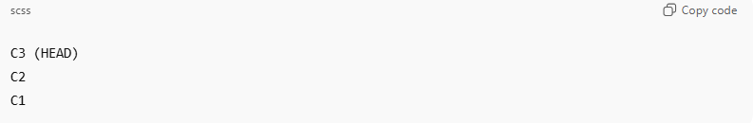
C3 (HEAD)
C2
C1
After:
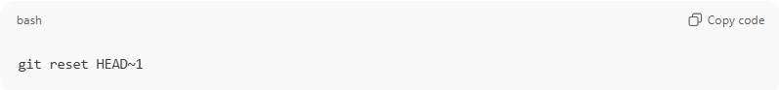
git reset HEAD~1
Becomes:
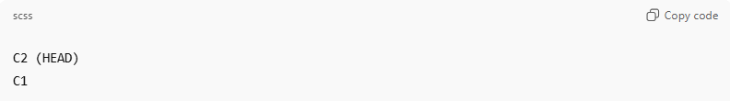
C2 (HEAD)
C1
Commit C3 is removed, but its changes stay in your files.

More examples
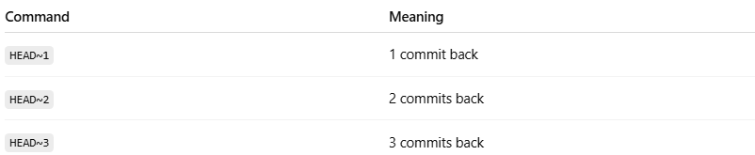
Command | Meaning
HEAD~1 | 1 commit back
HEAD~2 | 2 commits back
HEAD~3 | 3 commits back

HEAD^
# Source: AI Source: Provided by: [Data Path: Persons Table -> ID Column: 1, Name_En Column: Motasem Essam] -> From: [ChatGPT] on [2/15/2026]
HEAD^ = first parent of current commit
Usually same as HEAD~1, but important when dealing with merges.
Normal commit (no merge)
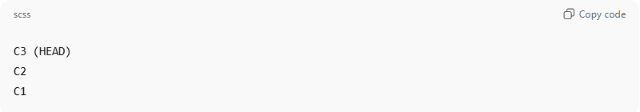
C3 (HEAD)
C2
C1
HEAD^ = C2 (same as HEAD~1)

Merge commit example
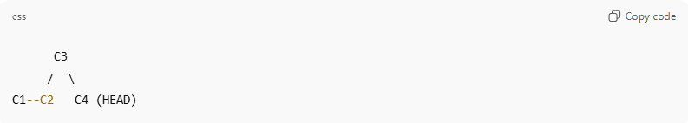
C3
/ \
C1--C2 C4 (HEAD)
Merge commit C4 has two parents:
- HEAD^ → first parent (usually main branch)
- HEAD^2 → second parent (merged branch)
So:
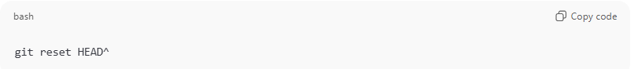
git reset HEAD^
Moves to first parent
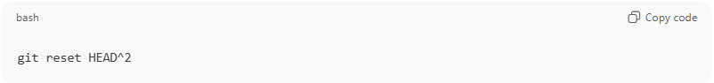
git reset HEAD^2
Moves to second parent

Summary
# Source: AI Source: Provided by: [Data Path: Persons Table -> ID Column: 1, Name_En Column: Motasem Essam] -> From: [ChatGPT] on [2/15/2026]
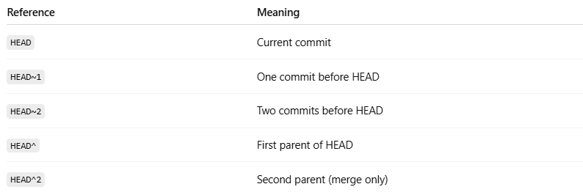
Reference | Meaning
HEAD | Current commit
HEAD~1 | One commit before HEAD
HEAD~2 | Two commits before HEAD
HEAD^ | First parent of HEAD
HEAD^2 | Second parent (merge only)

Common real-life uses
# Source: AI Source: Provided by: [Data Path: Persons Table -> ID Column: 1, Name_En Column: Motasem Essam] -> From: [ChatGPT] on [2/15/2026]
Undo last commit but keep changes:
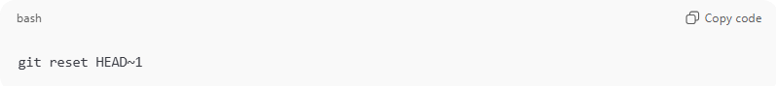
git reset HEAD~1
Undo last commit and delete changes:
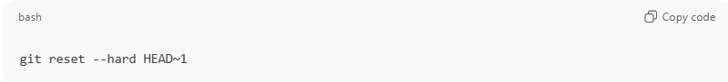
git reset --hard HEAD~1
Unstage files:
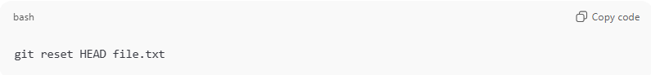
git reset HEAD file.txt

